**Report 1**

**Report that contain student detail which his/her guardian is a Co-operate grants (samurdhi)**

**Select**

a**.**ano **AS** **No** **,**

a**.**aname **AS** Adolescent_Name **,**

g**.**gname **AS** Guardian_Name **,**

g**.**RELATIONSHIP **AS** RELATIONSHIP

**From**

Adolescents a**,**

**TABLE(**a**.**Guardian**)** g

**where**

g**.**samurdhi**=**'Y'

**/**

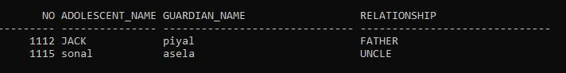

**Report 2**

**report that contain Adolescents details who is (age >18)**

**SELECT** a**.**aname**,** **TO_NUMBER(TO_CHAR(SYSDATE,**'YYYY'**))** **-** **TO_NUMBER(TO_CHAR(**a**.**dob**,**'YYYY'**))** **AS** AGE

**from** Adolescents a

**group** **by** a**.**aname **,** **TO_NUMBER(TO_CHAR(SYSDATE,**'YYYY'**))** **-** **TO_NUMBER(TO_CHAR(**a**.**dob**,**'YYYY'**))**

**having** **TO_NUMBER(TO_CHAR(SYSDATE,**'YYYY'**))** **-** **TO_NUMBER(TO_CHAR(**a**.**dob**,**'YYYY'**))>**18

**order** **by** a**.**aname**;**

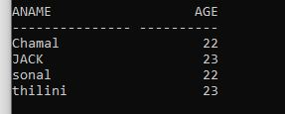

**Report 3**

**this report contains doctors who have assigned for more than one patient**

**SELECT**

a**.**adoctor**.**doctorid **AS** Doctor_ID**,**

a**.**adoctor**.**docname **AS** Doctor_Name**,**

**count(**a**.**adoctor**.**doctorid**)** **AS** No_of_patient

**FROM**

adolescents a

**group** **by**

a**.**adoctor**.**doctorid**,**a**.**adoctor**.**docname

**HAVING**

**count(**a**.**adoctor**.**doctorid**)** **>** 1**;**

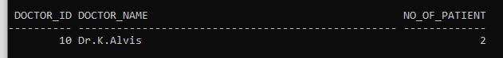

**Report 5**

**this report contains doctor details with thire created report count**

**select** **DISTINCT**

r**.**rdoctor**.**docname **AS** Doctor_name **,**

**count(**r**.**rdoctor**.**doctorid**)** Report_COUNT

**From**

medicalRecord r

**GROUP** **by** r**.**rdoctor**.**docname **;**

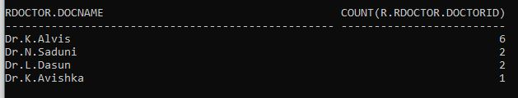

**Report 5**

**this report contains doctor details ,who is created more medical reports**

**select** **DISTINCT** r**.**rdoctor**.**docname **AS** Doctor_name **,** **count(**r**.**rdoctor**.**doctorid**)** **AS** Report_COUNT

**From** medicalRecord r

**GROUP** **by** r**.**rdoctor**.**docname

**Having** **count(**r**.**rdoctor**.**doctorid**)** **>=**

**All(** **SELECT** **count(**r**.**rdoctor**.**doctorid**)**

**From** medicalRecord r

**GROUP** **by** r**.**rdoctor**.**docname **);**

